|  |  |
| --- | --- |
| **Name:** | **Dhuware Chaitanya Rakesh** |
| **Roll Number:** | **20IM10009** |

**1.Aim of the experiment:**

* **Familiarisation with Resistor, Capacitor and Inductor**
* **Understanding Ohm’s Law**
* **Understanding Voltage Divider Arrangements**

**2.Tools used:**

* **Resistors, voltage source, connecting wires, voltmeter, ammeter, diode.**
* **VS Labs**
* **Falstad**

**3.Background knowledge (brief):**

* A **resistor** is a passive 2-terminal electrical component that implements resistance as a circuit element. It offers hindrance to the flow of electrons. It is measured in ohms where 1 ohm is the resistance offered when 1 A current flows across a potential difference of 1 V.
* In series R = R1 + R2 (current flow is same)
* In parallel 1/R = 1/R1 + 1/R2 (potential difference is same)
* A **capacitor** is a device that stores electrical energy in an electric field. The effect of a capacitor is known as capacitance. An ideal capacitor is characterized by a constant capacitance *C*, in farads in the SI system of units, defined as the ratio of the positive or negative charge *Q* on each conductor to the voltage *V* between them. A capacitance of one farad (F) means that one coulomb of charge on each conductor causes a voltage of one volt across the device. It resists potential change across it.
* An inductor, also called a coil, choke, or reactor, is a passive 2-terminal electrical component that stores energy in a magnetic field when electric current flows through it.
* It resists the change of current flowing through it and is in compliance to Lenz’s Law. An inductor is characterized by its inductance, which is the ratio of the voltage to the rate of change of current. 1 henry(H) is self-inductance of that coil in which 1V emf is produced when the rate of change of current in that coil is 1 A/s.
* Each of these components serve various roles in the electronics and are available in different types. Their values are usually colour-coded on them.

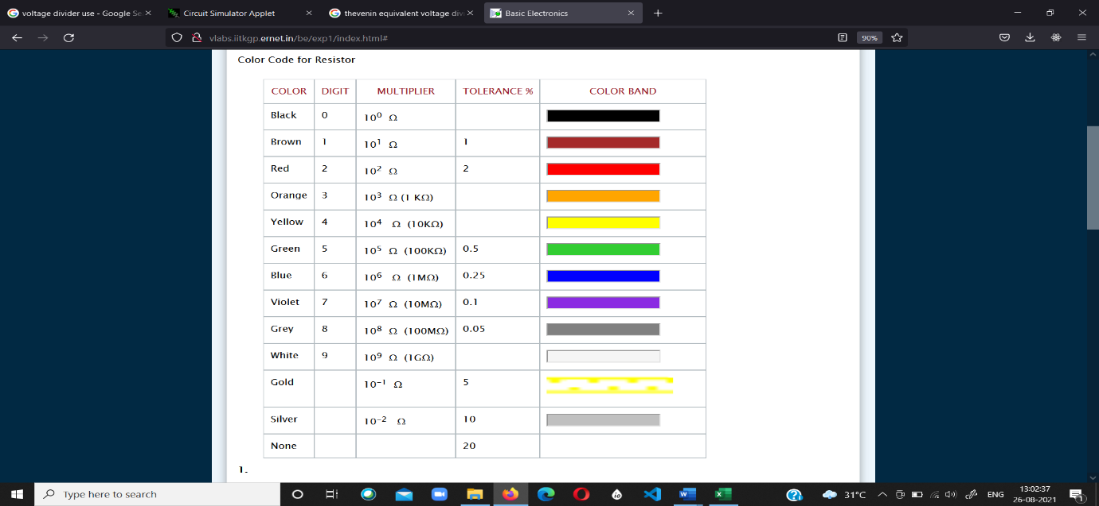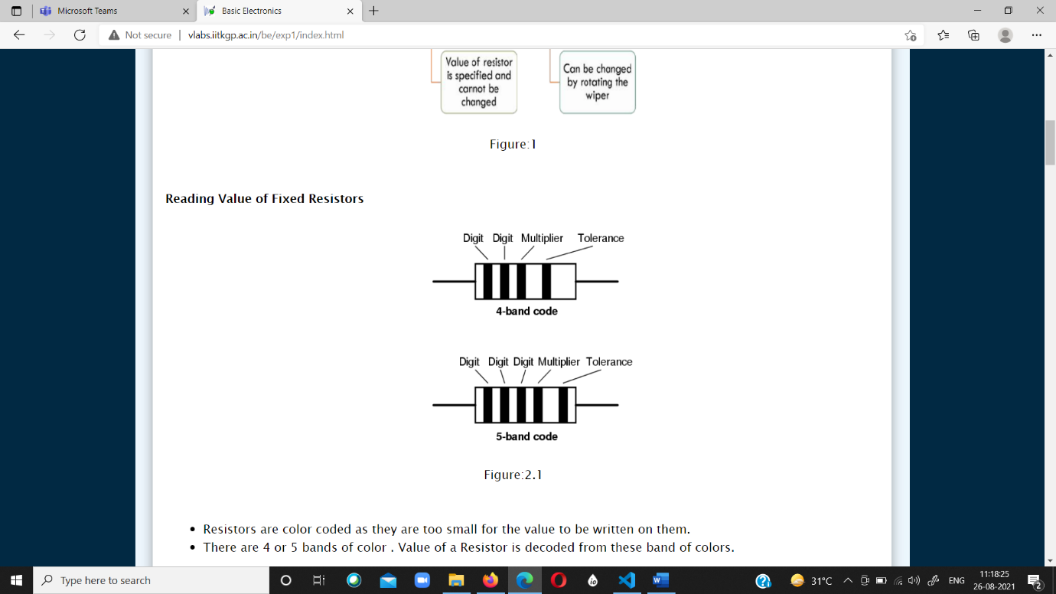

* Ohm’s law states that the current through a conductor between two points is directly proportional to the voltage across the two points. Such a conductor has its ‘Resistance’ – R (Ohms). The devices which follow Ohm’s law are called Ohmic devices like resistors while those that don’t follow are called non-ohmic devices like diodes, transistors etc.
* A **voltage divider** is a simple circuit which turns a large voltage into a smaller one. Using just two series resistors and an input voltage, we can create an output voltage that is a fraction of the input. A voltage divider involves applying a voltage source across a series of two resistors.
* For a voltage divider: Vout = Vin(R2/R1+R2).
* In Thevenin’s equivalent circuit of the voltage divider, the voltage source is replaced by an equivalent Thevenin’s voltage and all the resistors are replaced by a single equivalent Thevenin’s resistance.

**4.Circuit (hand drawn/image)**

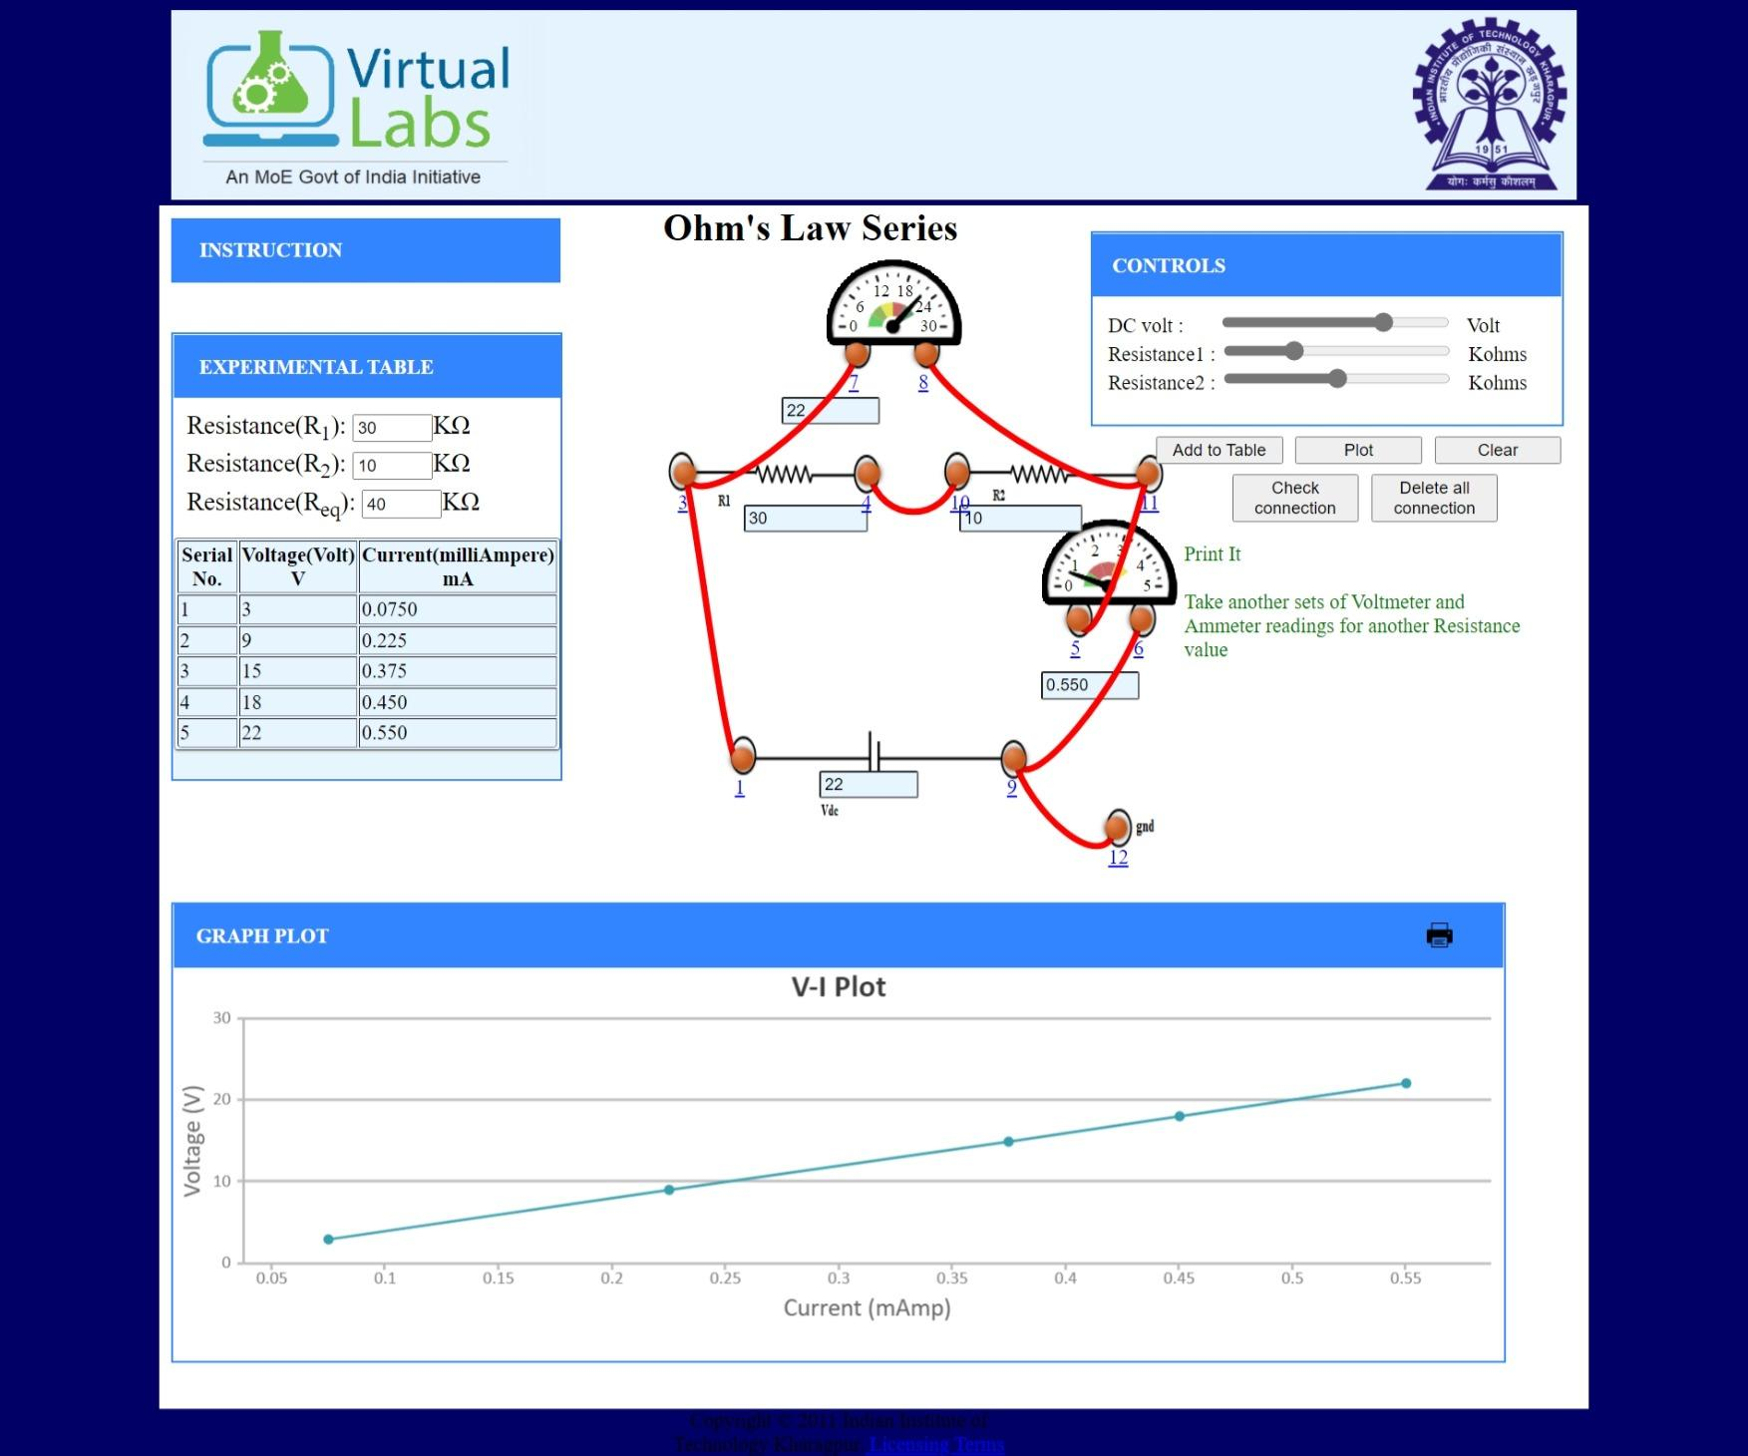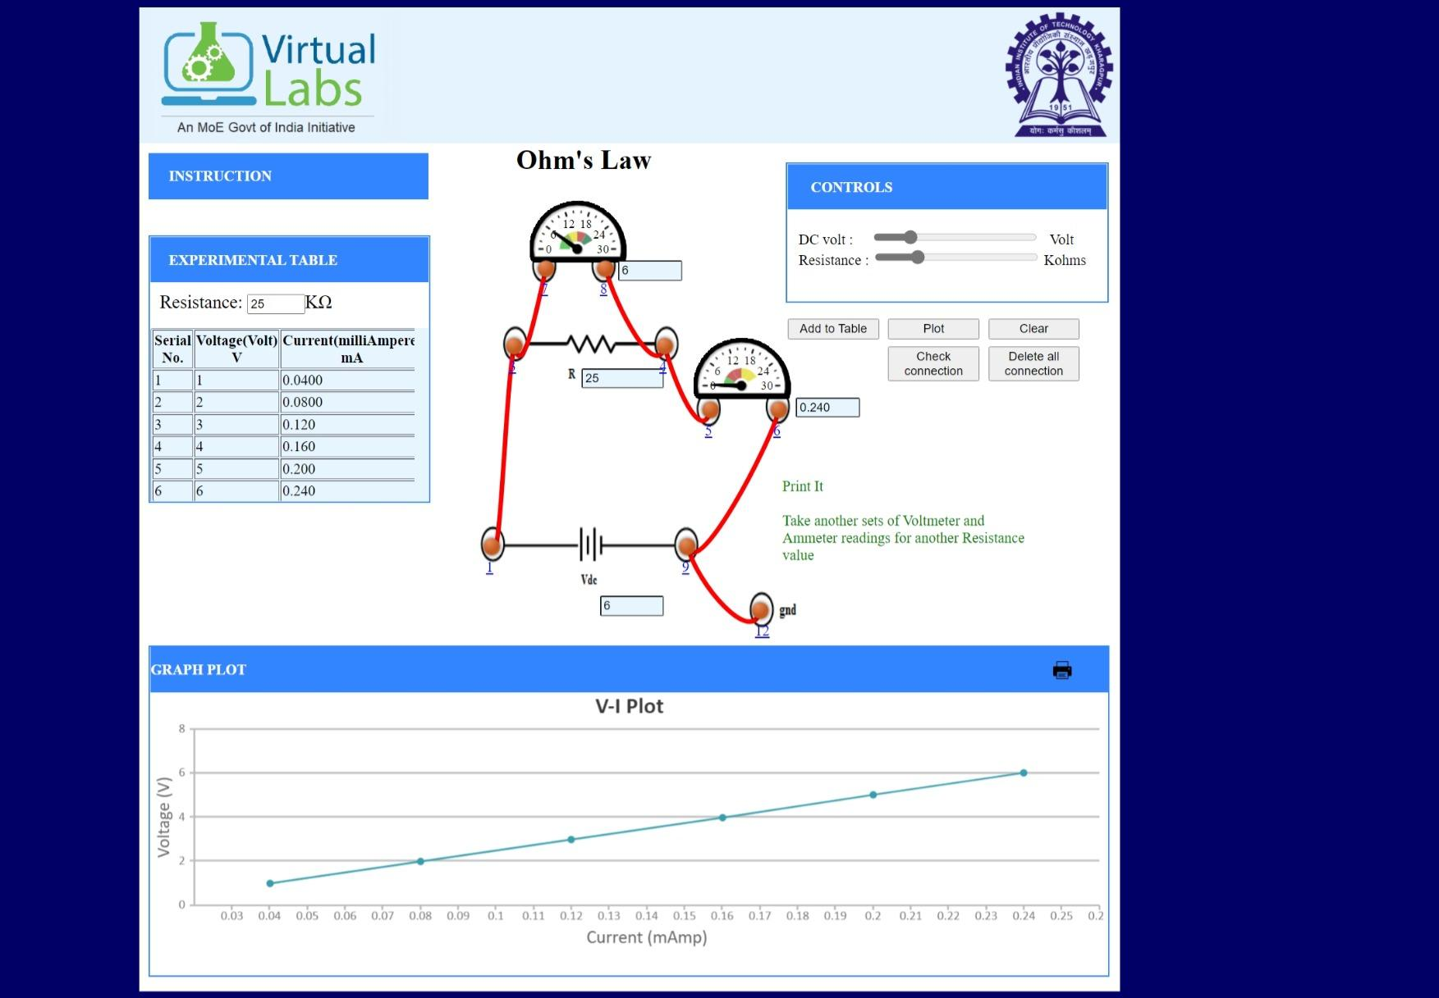

**Ohm’s Law Series**

**Ohm’s Law**

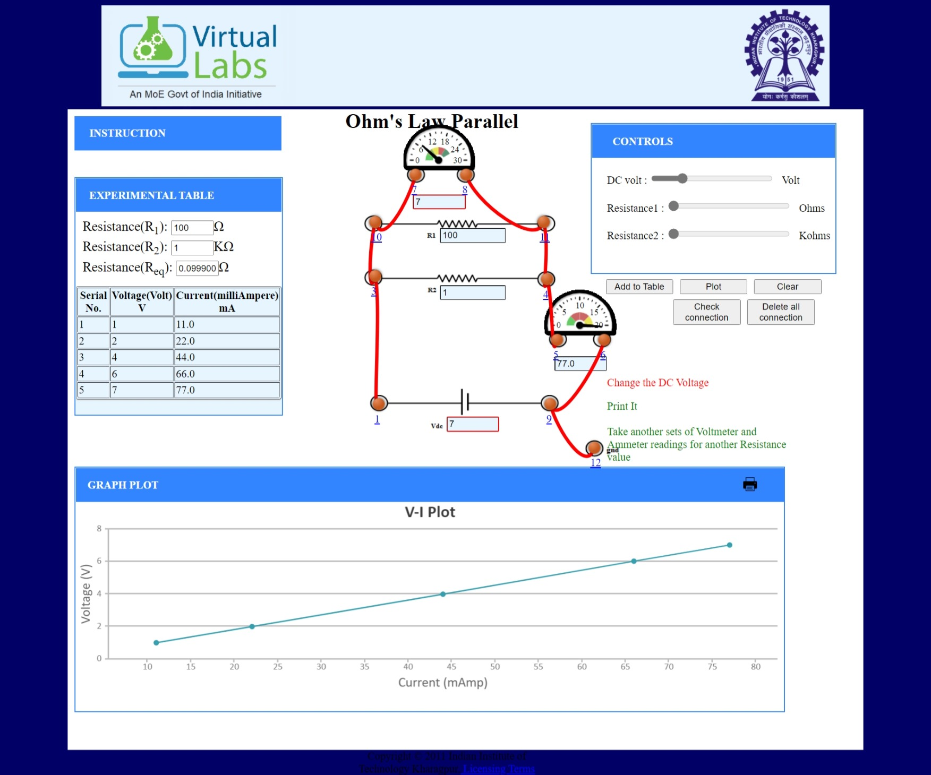

**Ohm’s Law Parallel**

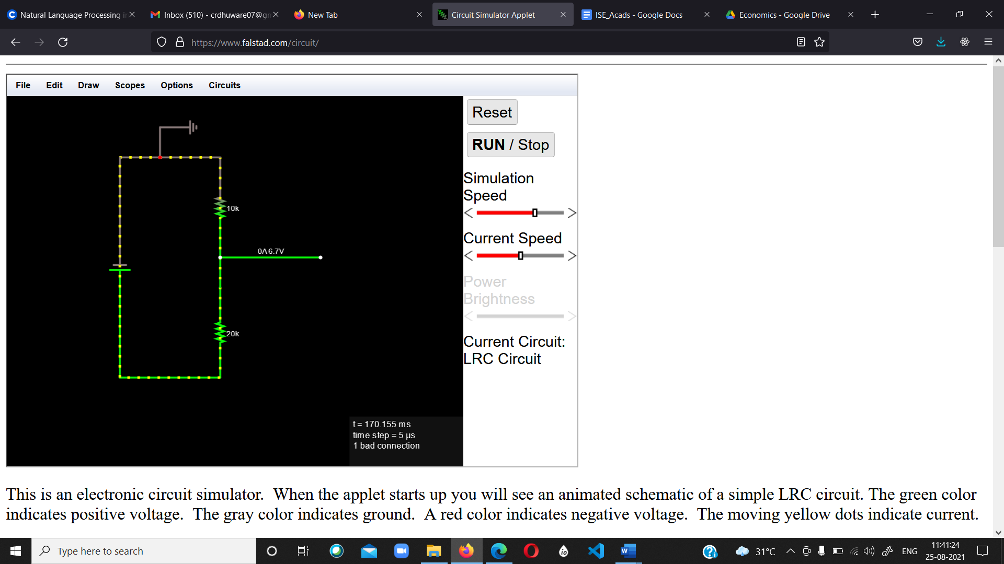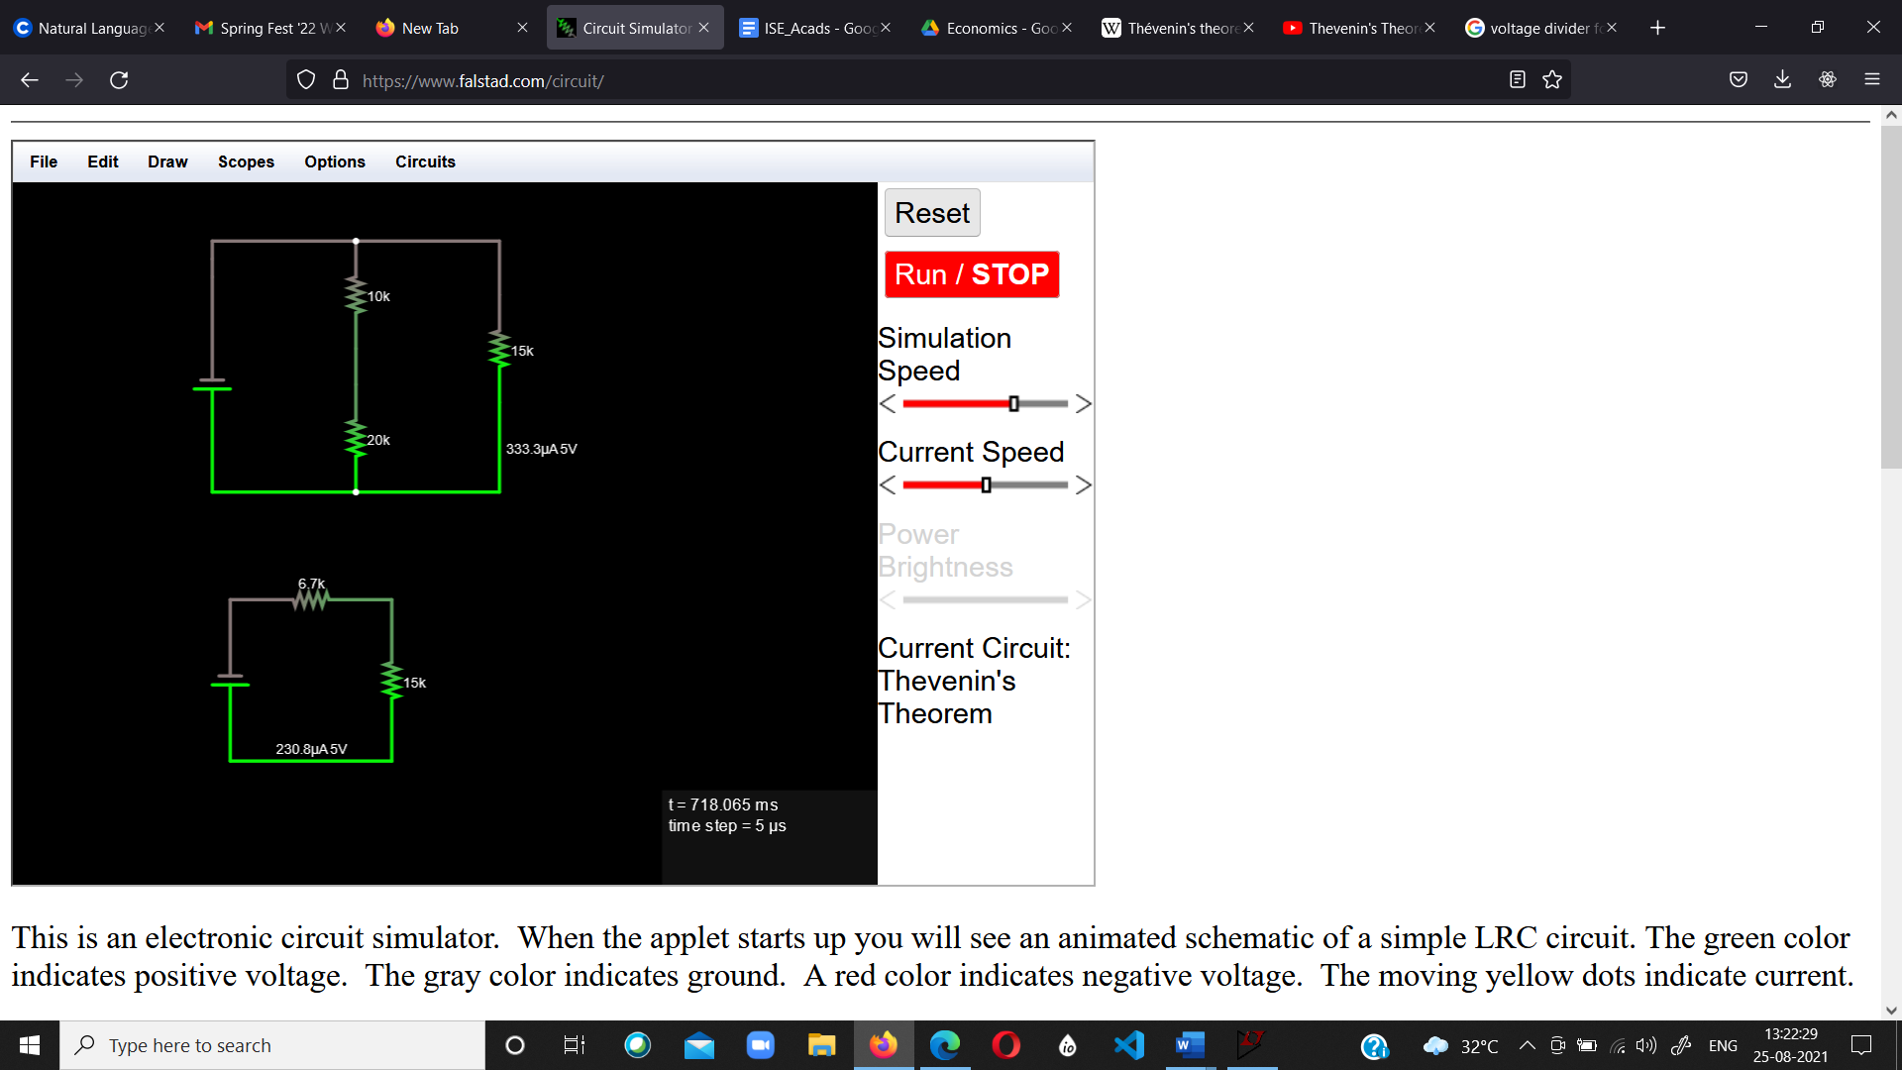

10 V

**Voltage Divider**

**Thevenin’s Voltage Divider**

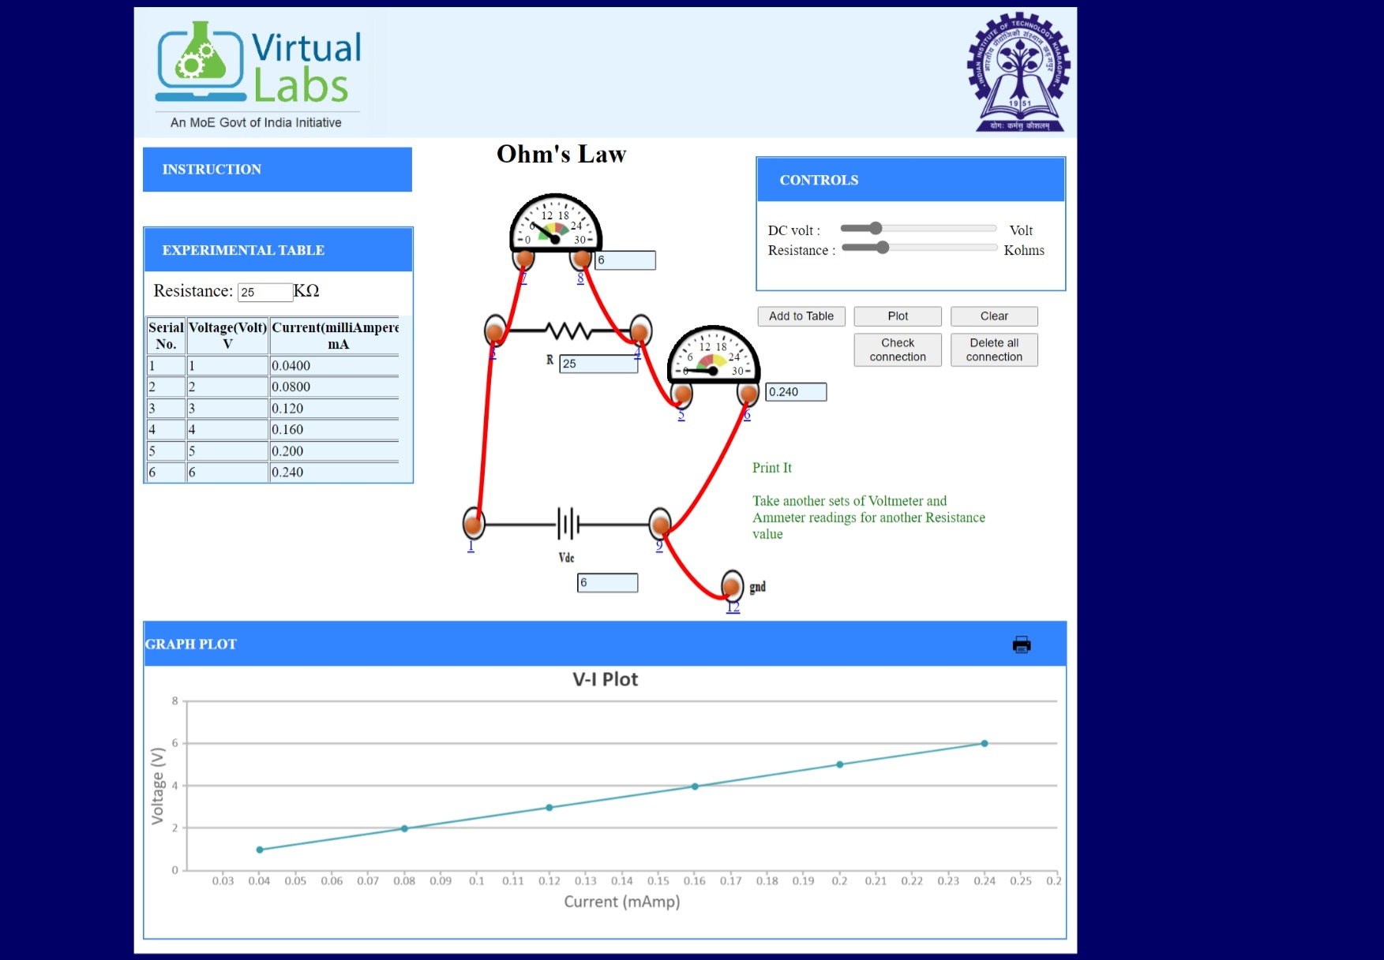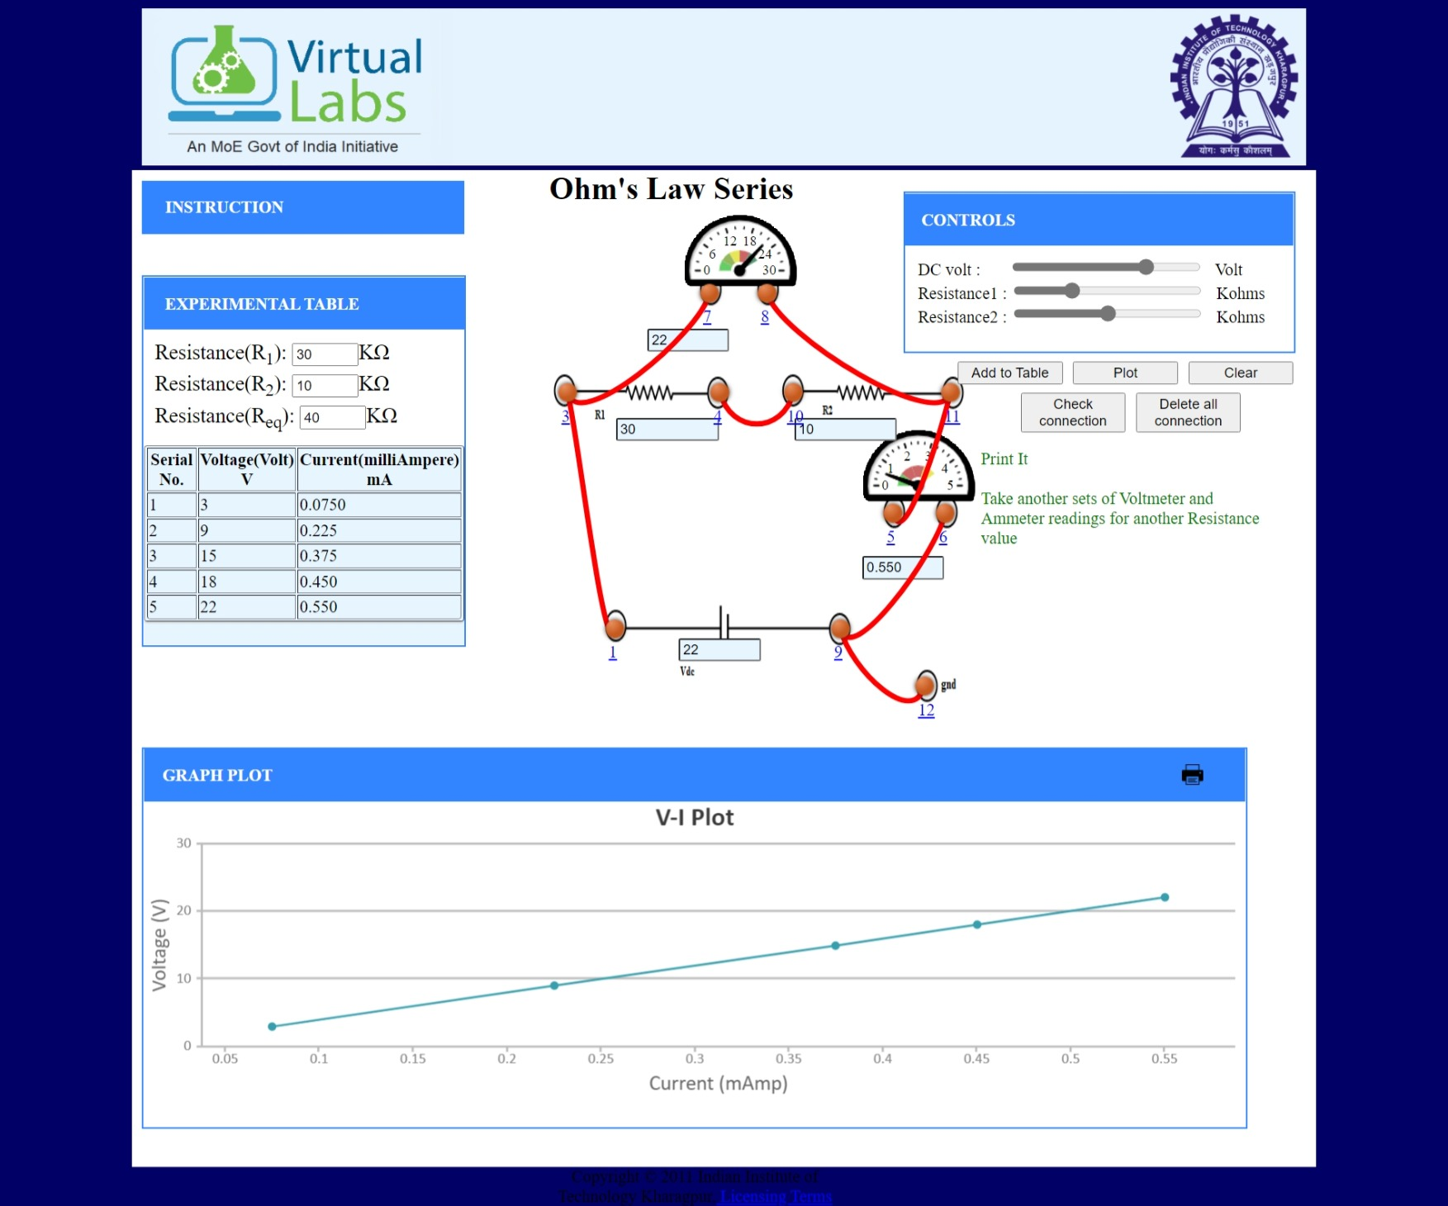**5.Measurement Data (Tabular form)**

**6.Graph (Image)/Screenshots**

**7.Conclusion**

* Ohms Law is followed by the combination of resistors in both series and parallel. A straight-line graph is obtained for both series and parallel combinations.
* The voltage divider calculations can be verified as:

Vout=Vin(R2/R1+R2)

= 10(20/20+10)

= 6.67 V which can be seen in the voltage divider circuit diagram.

* The Thevenin voltage (Vth) is an open circuit voltage across load terminals. The Thevenin resistance is the equivalent resistance across load terminals.

In the circuit for Thevenin Voltage Divider the Vth will be same as Vin and Rth is calculated as:

10K parallel to 20k i.e. = 30k

**8.Discussions**

* Resistors, capacitors and inductors are some of the basic passive elements of the circuit. Capacitors and inductors can be used as energy storing elements through electric field and magnetic field respectively.
* Resistors consists of color coded on them which can be used to determine their values as writing values on these small resistors is not possible.
* **Voltage Divider Circuits** are useful in providing different voltage levels from a common supply voltage.
* **Thevenin’s voltage divider is another way of simplifying the voltage divider circuit by replacing the voltage source by Vth and all resistors by Rth across the load.**